21. Plant Biology IV: Control Systems *(RHM: Chapter 37)*

______________________________________________________________________________

I. Introduction

II. Plant Hormones *(881-888)*

A. Auxins

1. Definition

2. Effects on cell elongation

3. Transport

4. Mode of action

5. Site of action

B. Cytokinins

1. Definition

2. Control of cell division and elongation

3. Transport

4. Cytokinin in *in vitro* cultures

5. Control of apical dominance

C. Gibberellins

1. Definition

2. Effect on stem elongation

3. Effect on fruit growth

4. Effect on germination

D. Ethylene

1. Definition

2. Senescence

3. Effect on fruit ripening

4. Effect on leaf abscission

III. Responses to Light: Biological Clocks *(903-908)*

A. Circadian Rhythms

B. Photoperiodism and the Control of Flowering

C. The Phytochrome System

1. endogenous rhythms

2. setting the clock

3. photoperiodism

21-1

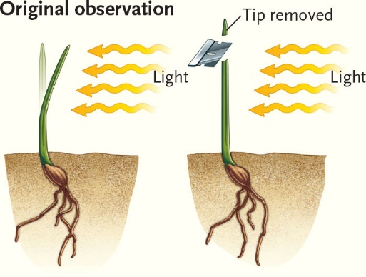 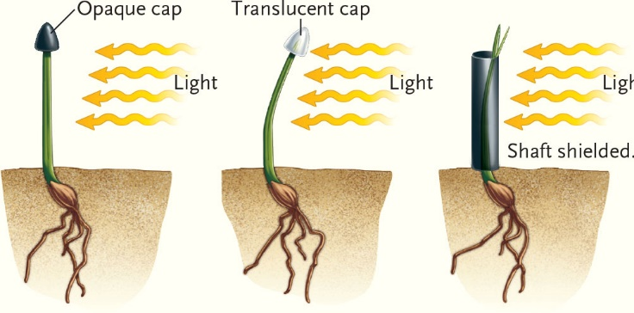

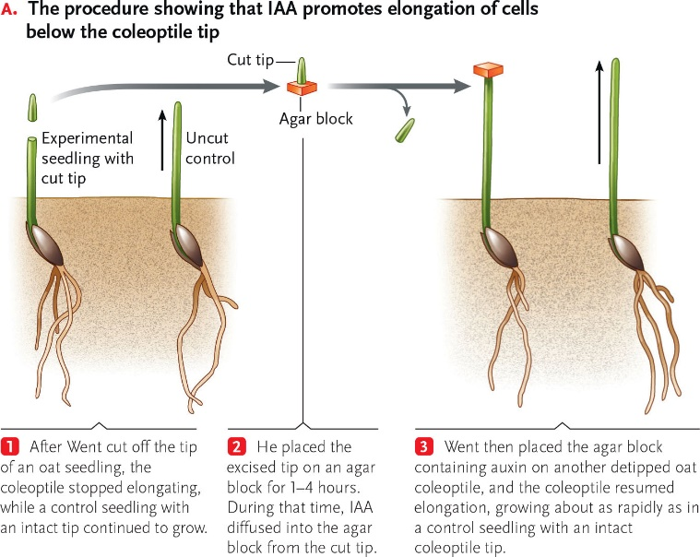

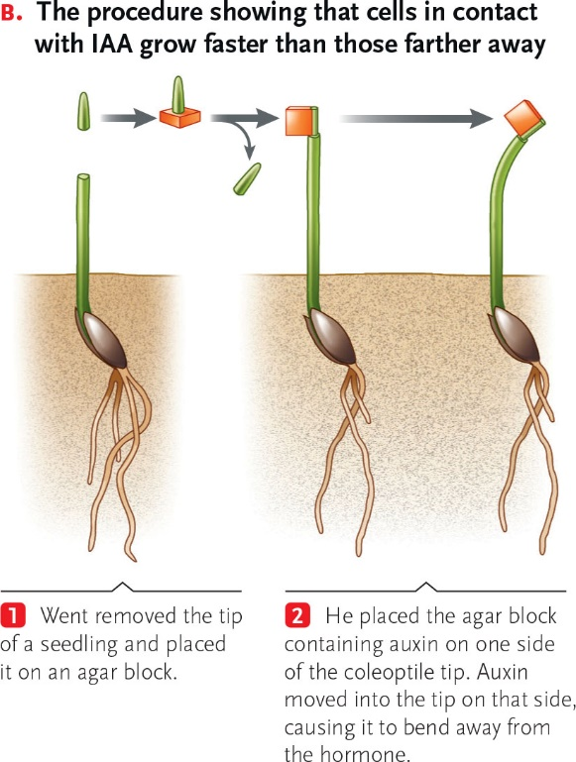

21-2

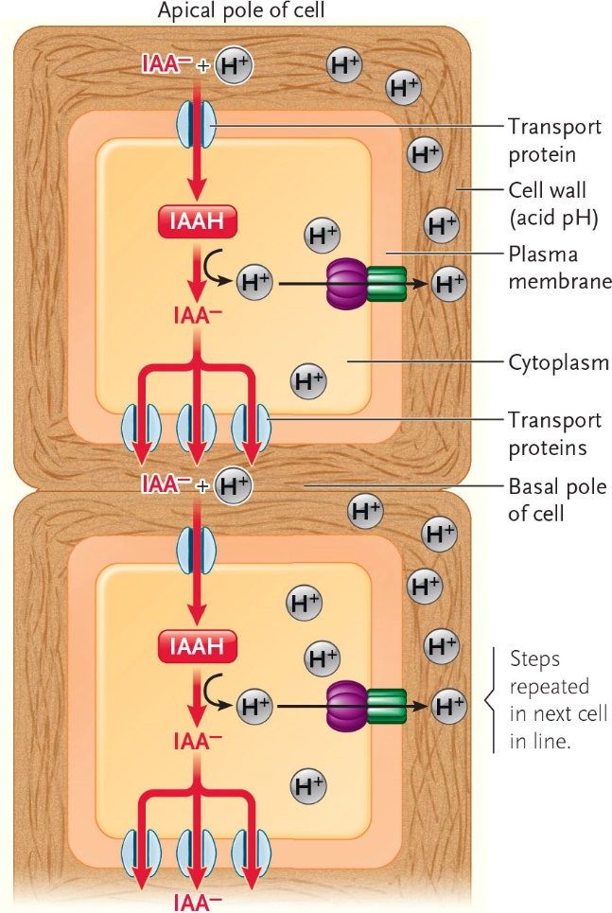

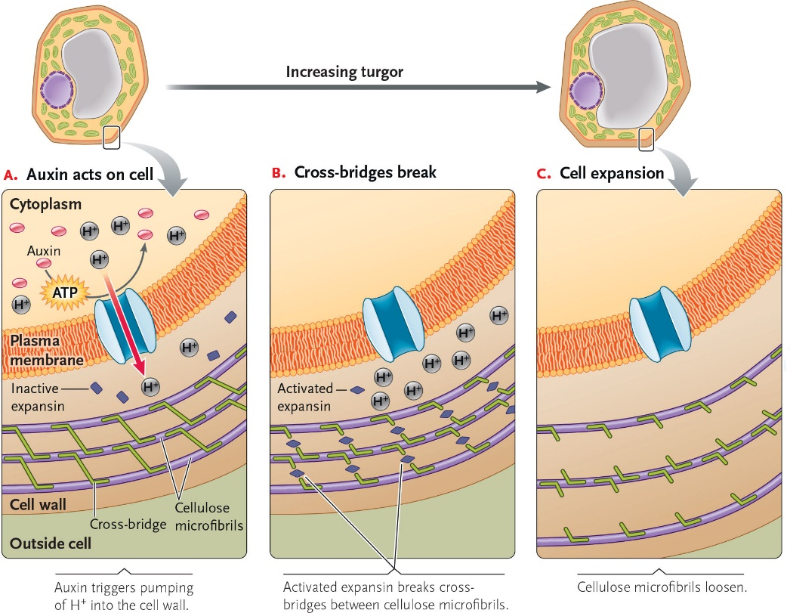

21-3

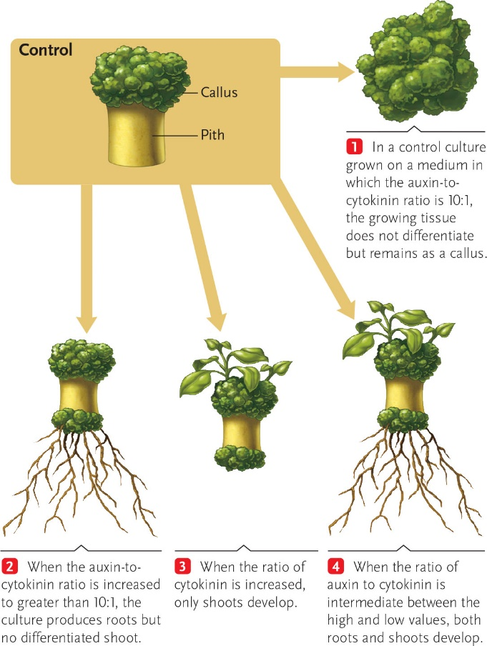

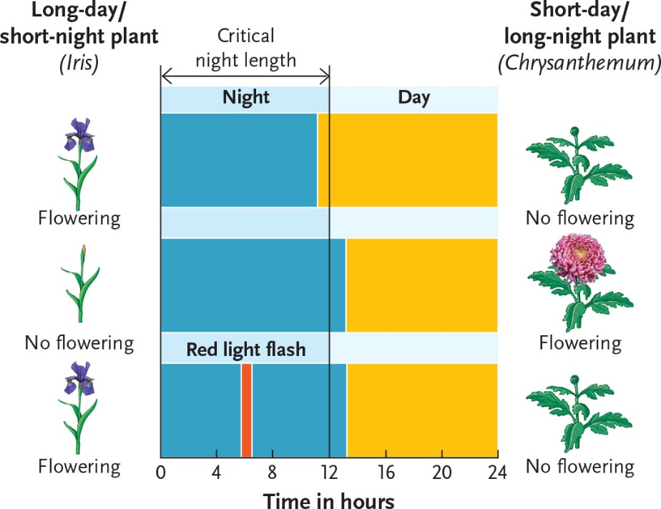

21-4

